Memo
Date: October 18, 2023
To: Academic Student Success Center
From: Diamond Johnson
Subject: Evaluating the Advising Appointment Scheduling Process at USF

Overview:

The University of South Florida (USF) has a highly effective and efficient Advising Appointment Scheduling Process that is easily comprehensible and user-friendly for students. The current process has been designed to meet student's needs and encourage their integration into the campus community. The following report delves into this process's intricacies, effectiveness, and advising's pivotal role in improving student success.

Why Advising is Important:

Advising appointments are vital in ensuring students' academic success, personal development, and overall campus experience at USF.

- Students often need assistance navigating the intricate web of degree requirements, course schedules, career selection and major/minor selection. Academic advisors assist students in charting a clear path through these complex academic landscapes, ensuring that they take the requisite courses at the appropriate time, ultimately leading to efficient degree progression and timely graduation.

- Beyond academics, advisory appointments can aid in personal development. Advisors often have knowledge of the various clubs, organizations, and leadership opportunities on campus. This insight encourages students to engage in extracurricular activities and become active campus community members, contributing to a well-rounded educational experience.

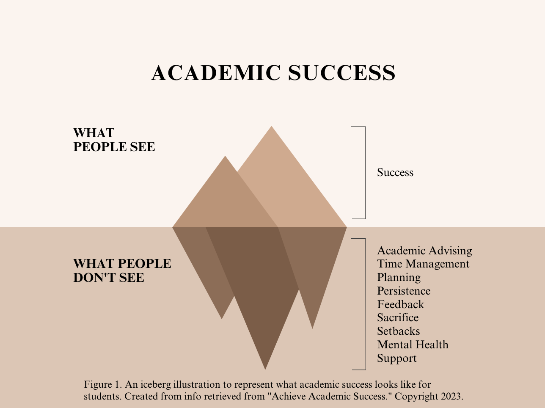

- As shown in Figure 1, academic success is not a single-factor achievement but a combination of many factors. While academic advising is essential, many other elements can help students achieve their goals. Therefore, it is necessary to consider all aspects of student success to ensure students can achieve their full potential.

Current Advising Appointment Scheduling Process:

- Students log in to the myUSF dashboard.
- Select the "Business Systems" drop-down and click "Archivum."
- Click on the “Student Portal” box at the bottom.
- Then click on “Appointment Scheduling.”
- Then click on “Book Appointment.”
- Choose an option for if they know their advisor or not.
- Next, click on the box that has their advisor.
- Next, click on how they would like to meet with their advisor and fill out the advising area via the dropdown buttons.
- Then, choose the date and time they would like for their appointment.
- Finally, find the confirmation of the advising appointment in their USF Outlook email.

Scheduling Advising Appointment Process Overview:

The Advising Appointment Scheduling Process at USF is a commendable system that sets a high standard for student-centric services. The well-structured process offers students a straightforward and intuitive approach, meeting their needs while effectively integrating them into the campus community.

- Accessibility is a crucial feature of the process, with the USF student portal providing a user-friendly platform that 100% of students found easy to use.

- The ability to choose preferred advisors fosters a more personalized advising experience, allowing students to establish personal connections with their advisors and contributing to a sense of belonging on campus.

- Communication is critical in ensuring that students are well-informed about their appointments. The system sends email confirmations and reminders, promoting student and advisor accountability.

The Research:

Through extensive research, I discovered that several colleges face a common issue of needing a comprehensive guide on scheduling an advising appointment.

- The University of Central Florida has a student success/academic center section that provides advising information, but I could not find a direct guide to scheduling an appointment. Instead, the resource directed me to multiple other sources.

- My research into Harvard University's advising scheduling showed me a direct link for scheduling an appointment. However, no step-by-step guides are available for scheduling an advising appointment.

- Scheduling an advising appointment is similar to planning a therapy session online or a doctor's appointment. For both these appointments, you need to specify the reason for your visit, fill out relevant information, select your doctor/therapist, and receive confirmation. Similarly, at USF, you can schedule an appointment for class scheduling for the next semester or a one-on-one meeting with a professor during their office hours.

The Effectiveness of the Process:

Scheduling advising appointments at USF is effective in streamlining access to essential academic services and supporting student success. This efficiency results from a well-structured and student-centric system that benefits the students and the university community.
- First and foremost, the process's effectiveness is evident in its accessibility. It is integrated into the USF student portal, making it easily accessible for all enrolled students. This user-friendly interface is a significant advantage, ensuring that students can easily initiate the appointment scheduling process. It eliminates potential barriers to accessing advising services, making it inclusive and straightforward for all students.

- The option for students to select their preferred advisors is another hallmark of the process's effectiveness. It enables a personalized advising experience, where students can connect with advisors who specialize in their chosen fields or whom they feel most comfortable working with. This personalization fosters a sense of ownership over one's academic journey and ensures that students receive guidance that aligns with their unique needs and goals.

- The availability of advising slots is crucial to the process's efficiency. With a wide range of appointment times and dates, students can choose slots that fit their schedules, minimizing the likelihood of scheduling conflicts. This flexibility ensures that students have ample opportunities to access advising services, even during peak registration periods, which is crucial for timely degree completion and academic success.

- Communication is another area where the process excels. Students receive email confirmations and reminders, keeping them well-informed about their upcoming advising appointments. This proactive approach to communication helps students stay organized and ensures they do not miss crucial advising sessions. It reflects the university's commitment to providing its students with a seamless and supportive environment.

What Students Think:

Students provided positive feedback on the process regarding my instructions and clarity on scheduling an advising appointment.

- I followed the step-by-step process shown in Figure 2, to schedule an advising appointment, and the instructions helped me do it smoothly without any issues or complications. The instructions were clear and concise, making it easy for me to understand each stage of the process and complete it successfully. Overall, the entire process was straightforward and efficient, and the well-crafted instructions only added to the ease of scheduling.

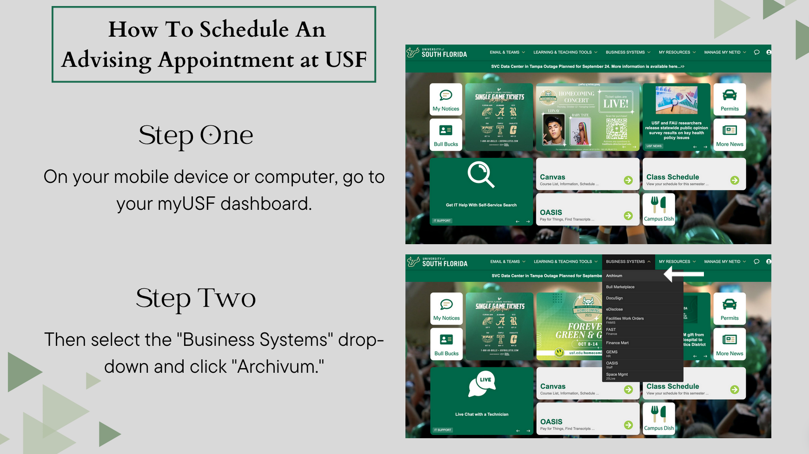
Figure 2. A screenshot of my previous project “How to Schedule
an Advising Appointment at USF”. Copyright 2023.

- During user testing for Figure 2, approximately ten students appreciated the convenience of online scheduling tools and easy-to-follow instructions.

- Three student interviews were conducted, and they all revealed that the advising process at USF plays a significant role in their academic integration and success. The personalized approach, advisor choice, and excellent communication contribute to the system's success.

- According to the feedback received, all thirteen students found the scheduling process to be easier than other things they must schedule in their day-to-day lives.

- One suggestion regarding Figure 2, was to post these instructions or similar ones on the website, which would help freshmen to understand the process clearly.

Conclusion:

The current Advising Appointment Scheduling Process at USF is a testament to the institution's commitment to student success. The accessibility, flexibility, and personalized approach offer a positive experience for students, meeting their needs while effectively integrating them into the campus community. I recommend continuously monitoring and assessing student feedback to ensure that the system remains aligned with students' evolving needs. Sharing best practices with other institutions can also serve as a model for success, promoting a better academic experience for students.

